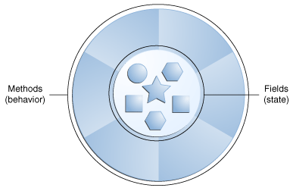
OOP Arial;Helvetica Neue;Helvetica;sans-serif

trebuchet ms
Software objects are conceptually similar to real-world objects: they too consist of state and related behavior.
An object stores its state in fields (variables in some programming languages) and exposes its behavior through methods (functions in some programming languages). Methods operate on an object's internal state and serve as the primary mechanism for object-to-object communication. Fields → the data inside the Object , what the object knows. Methods → what the object does.
Hiding internal state and requiring all interaction to be performed through an object's methods is known as data encapsulation (protecting our data), a fundamental principle of object-oriented programming. Java’da declaring kelimesi genelde definition (C/C++) olarak da kullanılıyor. Declaring : ilan etmek , bildirmek Definition : tanımlama, tarif etmek
Each bicycle was built from the same set of blueprints and therefore contains the same components. In object-oriented terms, we say that your bicycle is an instance of the class of objects known as bicycles.
A class is the blueprint from which individual objects are created.
Inheritance : In the Java programming language, each class is allowed to have one direct superclass, and each superclass has the potential for an unlimited number of subclasses
The compiler will require that methods declared in the Interface to be implemented. Compilation will fail if those methods are missing from this class. Interfaces form a contract between the class and the outside world, and this contract is enforced at build time by the compiler.
The Java programming language defines the following kinds of variables ...
- Having said that, the remainder of this tutorial uses the following general guidelines when discussing fields and variables.
If we are talking about "fields in general" (excluding local variables and parameters), we may simply say "fields". If the discussion applies to "all of the above", we may simply say "variables". If the context calls for a distinction, we will use specific terms (static field, local variables, etc.) as appropriate. You may also occasionally see the term "member" used as well. A type's fields, methods, and nested types are collectively called its members.

IN JAVA EVERYTHING IS PASSED/CALLED BY VALUE – (the object reference is coppied to a local variable)
ACCESSING OBJECTS HAPPENS WITH ONLY ‘REFERENCES’ (kind of pointers)
PRIMITIVE DATA TYPES DONT HAVE REFERENCES
Variables

The Java programming language defines the following kinds of variables:
- Instance Variables (Non-Static Fields)
- Class Variables (Static Fields)
- Local Variables - local variables are only visible to the methods in which they are declared; they are not accessible from the rest of the class.
- Parameters

Primitive Data Types --→ (byte, short, int, long, float, double, boolean, char)
Reference Data Types --→ Objects …
- The Java programming language is statically-typed, which means that all variables must first be declared before they can be used.
- By convention, the underscore character is never used elsewhere. Only static final int NUM_GEARS = 6, the convention changes slightly, capitalizing every letter and separating subsequent words with the underscore character

- FLOAT and DOUBLE should never be used for precise values, such as currency. For that, you will need to use the java.math.BigDecimal class instead.

- LONG: The long data type is a 64-bit two's complement INTEGER (Tamsayı , noktalı sayı veremezsin).

- Enclosing your character string within double quotes will automatically create a new String object; for example, String s = "this is a string";. String objects are immutable, which means that once created, their values cannot be changed.

- Fields that are declared but not initialized will be set to a reasonable default by the compiler. Generally speaking, this default will be zero or null, depending on the data type. Relying on such default values, however, [[is generally considered bad programming style]]
Local variables are slightly different; the compiler never assigns a default value to an uninitialized local variable.

- You may have noticed that the new keyword isn't used when initializing a variable of a primitive type. Primitive types are special data types built into the language; they ARE NOT objects created from a class.
- An integer literal is of type long if it ends with the letter L or l (SUFFIX) ; otherwise it is of type int. It is recommended that you use the upper case letter L because the lower case letter l is hard to distinguish from the digit 1 ( Prefix : 0x -hexadecimal , 0b - binary )
( float ends with F,f double ends with D,d scientific notation e,E)

- The Java programming language also supports a few special escape sequences for char and String literals: \b (backspace), \t (tab), \n (line feed), \f (form feed), \r (carriage return), \" (double quote), \' (single quote), and \\ (backslash).

- There's also a special null literal and a .class literal, for example, String.class. This refers to the object (of type Class) that represents the type itself.

- if your code contains numbers with many digits, you can use an underscore character to separate digits in groups of three which can improve the readability of your code.
long socialSecurityNumber = 999_99_9999L; byte nybbles = 0b0010_0101;
Arrays

- An array is a container object that holds a fixed number of values of a single type. The length of an array is established when the array is created. After creation, its length is fixed.
- Each item in an array is called an element

// declares an array of integers // initialize first element
int[] anArray; anArray[0] = 100;

// allocates memory for 10 integers
anArray = new int[10];

- As with variables of other types, the declaration does not actually create an array; it simply tells the compiler that this variable will hold an array of the specified type.
- You can also place the brackets after the array's name:
// this form is discouraged
float anArrayOfFloats[ ];

However, convention discourages this form; the brackets identify the array type and should appear with the type designation.
- You can create an array by using the new operator

  - dataType[] arrayRefVar = new dataType[arraySize];

- Alternatively, you can use the shortcut syntax to create and initialize an array:
int[ ] anArray = {
100, 200, 300,
400, 500, 600,
700, 800, 900, 1000
};

Copying Arrays

Coppying options for an array :
    - Loop ( coppy each element to the other array)
    - with .clone() , which is too slow
    - System.arraycopy (Object src, int srcPos, Object dest, int destPos, int length)
    - java.util.Arrays.copyOfRange (Object src,int srcBegin, int srcEnd);
Begin : inclusive --- End : exclusive

Array Manipulations

Java SE provides several methods for performing array manipulations (common tasks, such as copying, sorting and searching arrays) in the java.util.Arrays class

- The difference is that using the copyOfRange method does not require you to create the destination array before calling the method, because the destination array is returned by the method. System.arraycopy doesnt return an array object.
Some other useful operations provided by methods in the java.util.Arrays class, are:
- Searching an array for a specific value to get the index at which it is placed (the binarySearch method).
- Comparing two arrays to determine if they are equal or not (the equals method).
- Filling an array to place a specific value at each index (the fill method).
- Sorting an array into ascending order. This can be done either sequentially, using the sort method, or concurrently, using the parallelSort method introduced in Java SE 8. Parallel sorting of large arrays on multiprocessor systems is faster than sequential array sorting.

Operators

Operators with higher precedence are evaluated before operators with relatively lower precedence
All binary operators except for the assignment operators are evaluated from left to right; assignment operators are evaluated right to left.

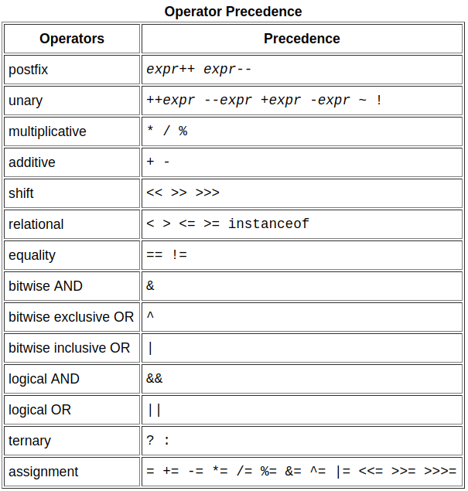
Operand : işlenen , işlemci , terim

compound assignments : e.g. x += 1;

+ operator can also be used for concatenating (joining) two strings

- The unary operators require only one operand; they perform various operations such as incrementing/decrementing a value by one, negating an expression, or inverting the value of a boolean.
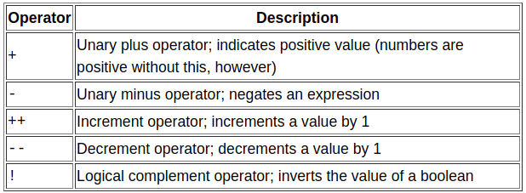

- The increment/decrement operators can be applied before (prefix) or after (postfix) the operand. The code result++; and ++result; will both end in result being incremented by one.
- The only difference is that the prefix version (++result) evaluates to the incremented value, whereas the postfix version (result++) evaluates to the original value. ++a increments and then uses the variable. [Same as C language]
a++ uses and then increments the variable.

The Type Comparison Operator instanceof
The instanceof operator compares an object to a specified type. You can use it to test if an object is an instance of a class, an instance of a subclass, or an instance of a class that implements a particular interface.

(obj1 instanceof Parent) → Returns true or false

Expressions, Statements, and Blocks

Operators may be used in building expressions, which compute values; expressions are the core components of statements; statements may be grouped into blocks.

- An expression is a construct made up of variables, operators, and method invocations, which are constructed according to the syntax of the language, that evaluates to a single value. (computes values)

the following expression gives different results, depending on whether you perform the addition or the division operation first:

x + y / 100 // ambiguous

You can specify exactly how an expression will be evaluated using balanced parenthesis: ( and ). For example, to make the previous expression unambiguous, you could write the following:
(x + y) / 100 // unambiguous, recommended
- Statements are roughly equivalent to sentences in natural languages. A statement forms a complete unit of execution. The following types of expressions can be made into a statement by terminating the expression with a semicolon (;). Such statements are called expression statements

- Assignment expressions
- Any use of ++ or --
- Method invocations
- Object creation expressions

- In addition to expression statements, there are two other kinds of statements: declaration statements and control flow statements.
  - A declaration statement declares a variable.
  - control flow statements regulate the order in which statements get executed.

- A block is a group of zero or more statements between balanced braces and can be used anywhere a single statement is allowed.

Control Flow Statements

The statements inside your source files are generally executed from top to bottom, in the order that they appear. Control flow statements, however, break up the flow of execution by employing decision making, looping, and branching, enabling your program to conditionally execute particular blocks of code

- The if-then statement is the most basic of all the control flow statements. It tells your program to execute a certain section of code only if a particular test evaluates to true.
The opening and closing braces are optional, provided that the "then" clause contains only one statement
if (isMoving) {
currentSpeed--; }
Omitting (atlamak) them can make the code more brittle (kırılgan). If a second statement is later added to the "then" clause, a common mistake would be forgetting to add the newly required braces.

- The if-then-else statement provides a secondary path of execution when an "if" clause evaluates to false.

- A switch works with the byte, short, char, and int primitive data types. It also works with enumerated type the String class, and a few special classes that wrap certain primitive types: Character, Byte, Short, and Integer
switch (month) {
case 1: monthString = "January";
break;
case 2: monthString = "February";
break;
...
default: monthString = "Invalid month";
break;
The following code example shows how a statement can have multiple case labels.

switch (month) {
case 1: case 3: case 5: int month = 2;
case 7: case 8: case 10: int year = 2000;
case 12: int numDays = 0;
numDays = 31;
break;
case 4: case 6:
case 9: case 11:
numDays = 30;
break;
case 2:
if (((year % 4 == 0) &&
!(year % 100 == 0))
|| (year % 400 == 0))
numDays = 29;
else
numDays = 28;
break;
default:
System.out.println("Invalid month."); // Number of Days = 29
break;
}

In Java SE 7 and later, you can use a String object in the switchstatement's expression.
displays the number of the month based on the value of the String named month:

public static int getMonthNumber(String month) {

int monthNumber = 0;

if (month == null) { // Ensure that the expression in any switch statement is not null to
return monthNumber; // prevent a NullPointerException from being thrown
}

switch (month.toLowerCase()) {
case "january":
monthNumber = 1;
break;
case "february":
monthNumber = 2;
break;
case "march":
...
default:
monthNumber = 0;
break;
}
return monthNumber;
}

- The while statement continually executes a block of statements while a particular condition is true.
while (expression) {
statement(s)
}
- A do-while statement, which can be expressed as follows:
do {
statement(s)
} while (expression);

- The for statement provides a compact way to iterate over a range of values.
for (initialization; termination (test) ; increment) {
statement(s)
}
If the code declares a variable within the initialization expression , for(int i = 0; i < 10; i++) :
The scope of this variable is the for block, it can be used in the termination and increment expressions as well

The three expressions of the for loop are optional
// infinite loop
for ( ; ; ) {
// your code goes here
}

- The for-each loop . The for statement also has another form designed for iteration through Collections and arrays. This form is sometimes referred to as the enhanced for statement

int[] numbers = {1,2,3,4,5,6,7,8,9,10};
for (int item : numbers) {
System.out.println("Count is: " + item);
}

We recommend using this form of the for statement instead of the general form whenever possible.
This code works for any object that implements the Iterable interface.

The break Statement

- The break statement has two forms: labeled and unlabeled.
You can also use an unlabeled break to terminate a for, switch, while, or do-while loop

- An unlabeled break statement terminates the innermost switch, for, while, or do-while statement, but a labeled break terminates an outer statement.

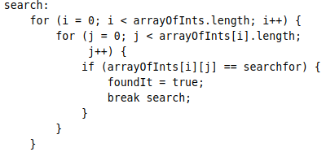

The continue Statement
- The continue statement skips the current iteration of a for, while , or do-while loop.
  - The unlabeled form skips to the end of the innermost loop's body and evaluates the boolean expression that controls the loop.
  - A labeled continue statement skips the current iteration of an outer loop marked with the given label.

The return Statement
- The return statement exits from the current method, and control flow returns to where the method was invoked.
  - The return statement has two forms: one that returns a value, and one that doesn't.

Classes

In general, class declarations can include these components, in order:
- Modifiers such as public, private, and a number of others that you will encounter later.
- The class name, with the initial letter capitalized by convention.
- The name of the class's parent (superclass), if any, preceded by the keyword extends. A class can only extend (subclass) one parent.
- A comma-separated list of interfaces implemented by the class, if any, preceded by the keyword implements. A class can implement more than one interface.
- The class body, surrounded by braces, {}.
There are several kinds of variables:
- Member variables in a class—these are called fields.
- Variables in a method or block of code—these are called local variables.
- Variables in method declarations—these are called parameters.

Access (Control) Modifiers

- public modifier—A class, method, constructor, interface, etc. is accessible from all classes from everywhere.
- No modifier (package-private) Default- it is visible only within its own package.
- private modifier—Methods, fields, and constructors that are declared private can only be accessed within the declared class itself.
- Protected - Variables, methods, and constructors, which are declared protected in a superclass can be accessed only by the subclasses in other package or any class within the package of the protected members' class.

Class and interfaces cannot be private. Methods and fields in a interface cannot be declared protected or private.

Access Control and Inheritance

The following rules for inherited methods are enforced −
- Methods declared public in a superclass also must be public in all subclasses.
- Methods declared protected in a superclass must either be protected or public in subclasses; they cannot be private.
- Methods declared private are not inherited at all, so there is no rule for them.
Naming a Method

- By convention, method names should be a verb in lowercase or a multi-word name that begins with a verb in lowercase, followed by adjectives, nouns, etc. In multi-word names, the first letter of each of the second and following words should be capitalized.

Run runFast getBackground getFinalData compareTo setX isEmpty

Overloading Methods

- The Java programming language supports overloading methods, and Java can distinguish between methods with different method signatures. (different parameter types, number of parameters)
Note: Overloaded methods should be used sparingly, as they can make code much less readable.

Providing Constructors for Your Classes

A class contains constructors that are invoked to create objects from the class blueprint. Constructor declarations look like method declarations—except that they use the name of the class and have no return type. To create a new Bicycle object called myBike, a constructor is called by the new operator.
Bicycle myBike = new Bicycle(30, 0, 8);
new Bicycle(30, 0, 8) creates space in memory for the object and initializes its fields.

- You don't have to provide any constructors for your class, but you must be careful when doing this. The compiler automatically provides a no-argument, default constructor for any class without constructors. This default constructor will call the no-argument constructor of the superclass. In this situation, the compiler will complain if the superclass doesn't have a no-argument constructor so you must verify that it does. If your class has no explicit superclass, then it has an implicit superclass of Object, which does have a no-argument constructor.

Note: If another class cannot call a MyClass constructor, it cannot directly create MyClass objects.

You can use a superclass constructor yourself. …..

Note: If you want to pass a method into a method, then use a lambda expression or a method reference.

Arbitrary Number of Arguments

You can use a construct called varargs to pass an arbitrary number of values to a method. You use varargs when you don't know how many of a particular type of argument will be passed to the method. It's a shortcut to creating an array manually
The method can be called either with an array or with a sequence of arguments. The code in the method body will treat the parameter as an array in either case.

- A parameter can have the same name as one of the class's fields. If this is the case, the parameter is said to shadow the field. Shadowing fields can make your code difficult to read and is conventionally used only within constructors and methods that set a particular field.

Objects

As you know, a class provides the blueprint for objects; you create an object from a class. Each of the following statements taken from the CreateObjectDemo program creates an object and assigns it to a variable:
Point originOne = new Point(23, 94);
Rectangle rectOne = new Rectangle(originOne, 100, 200);
Rectangle rectTwo = new Rectangle(50, 100);

The first line creates an object of the Point class, and the second and third lines each create an object of the Rectangle class.
Each of these statements has three parts (discussed in detail below):
- Declaration: The code set in bold are all variable declarations that associate a variable name with an object type.
- Instantiation: The new keyword is a Java operator that creates the object.
- Initialization: The new operator is followed by a call to a constructor, which initializes the new object.

Declaring a Variable to Refer to an Object

Previously, you learned that to declare a variable, you write:
type name;
This notifies the compiler that you will use name to refer to data whose type is type. With a primitive variable, this declaration also reserves the proper amount of memory for the variable.

You can also declare a reference variable on its own line. For example:
Point originOne;

If you declare originOne like this, its value will be undetermined until an object is actually created and assigned to it. Simply declaring a reference variable does not create an object. For that, you need to use the new operator, as described in the next section. You must assign an object to originOne before you use it in your code. Otherwise, you will get a compiler error.
Creating an Object

The new operator instantiates a class by allocating memory for a new object and returning a reference to that memory. This reference is usually assigned to a variable of the appropriate type. The new operator also invokes the object constructor.
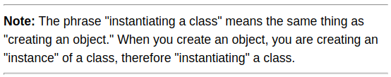

The reference returned by the new operator does not have to be assigned to a variable. It can also be used directly in an expression. For example:
int height = new Rectangle().height;

Garbage Collection

The Java runtime environment deletes objects periodically when it determines that they are no longer being used. This process is called garbage collection.

An object is eligible for garbage collection when there are no more references to that object. References that are held in a variable are usually dropped when the variable goes out of scope. Or, you can explicitly drop an object reference by setting the variable to the special value null. Remember that a program can have multiple references to the same object; all references to an object must be dropped before the object is eligible for garbage collection.

Returning a Class or Interface

When a method uses a class name as its return type, the class of the type of the returned object must be either a subclass of, or the exact class of, the return type.

- Covariant return type , means that when one overrides a method, the return type of the overriding method is allowed to be a subtype of the overridden method's return type.

Using the this() Keyword

Within an instance method or a constructor, this is a reference to the current object — the object whose method or constructor is being called. You can refer to any member of the current object from within an instance method or a constructor by using this.

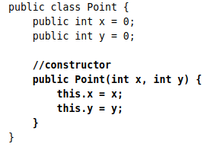
- The most common reason for using the this keyword is because a field is shadowed by a method or constructor parameter.

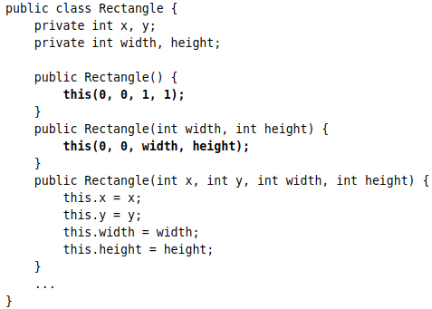
you can also use the this keyword to call another constructor in the same class. Doing so is called an explicit constructor invocation.
- If present, the invocation of another constructor must be the first line in the constructor.

Class Variables

Fields that have the static modifier in their declaration are called static fields or class variables. They are associated with the class, rather than with any object. Every instance of the class shares a class variable, which is in one fixed location in memory. Any object can change the value of a class variable, but class variables can also be manipulated without creating an instance of the class.
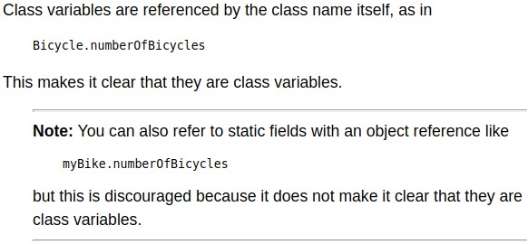

Class Methods

Static methods, which have the static modifier in their declarations, should be invoked with the class name, without the need for creating an instance of the class, as in ClassName.methodName(args)

- Note: You can also refer to static methods with an object reference like but this is discouraged because it does not make it clear that they are class methods.
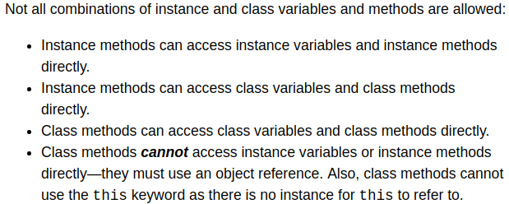

Constants

The static modifier, in combination with the final modifier, is also used to define constants. The final modifier indicates that the value of this field cannot change.
Initializing Fields

You can often provide an initial value for a field in its declaration This works well when the initialization value is available and the initialization can be put on one line. However, this form of initialization has limitations because of its simplicity. If initialization requires some logic (for example, error handling or a for loop to fill a complex array), simple assignment is inadequate. Instance variables can be initialized in constructors, where error handling or other logic can be used. To provide the same capability for class variables, the Java programming language includes static initialization blocks.
- Note: It is not necessary to declare fields at the beginning of the class definition, although this is the most common practice. It is only necessary that they be declared and initialized before they are used.

Static Initialization Blocks
A static initialization block is a normal block of code enclosed in braces, { }, and preceded by the static keyword. There is an alternative to static blocks — you can write a private static method.

Initializing Instance Members
Normally, you would put code to initialize an instance variable in a constructor. There are two alternatives to using a constructor to initialize instance variables: initializer blocks and final methods.

- Initializer blocks for instance variables look just like static initializer blocks, but without the static keyword. The Java compiler copies initializer blocks into every constructor. Therefore, this approach can be used to share a block of code between multiple constructors.
- A final method cannot be overridden in a subclass. This is discussed in the lesson on interfaces and inheritance.

Nested Classes

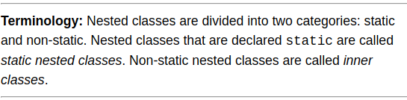
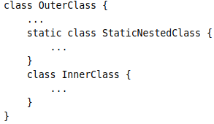

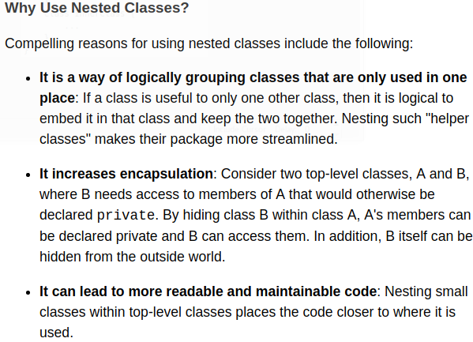

A nested class is a member of its enclosing class.
- Non-static nested classes (inner classes) have access to other members of the enclosing class, even if they are declared private.
- Static nested classes do not have access to other members of the enclosing class. As a member of the OuterClass, a nested class can be declared private, public, protected, or package private. (Recall that outer classes can only be declared public or package private.)
- An instance of InnerClass can exist only within an instance of OuterClass and has direct access to the methods and fields of its enclosing instance.
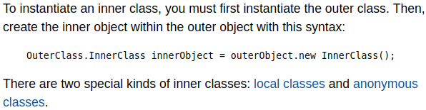

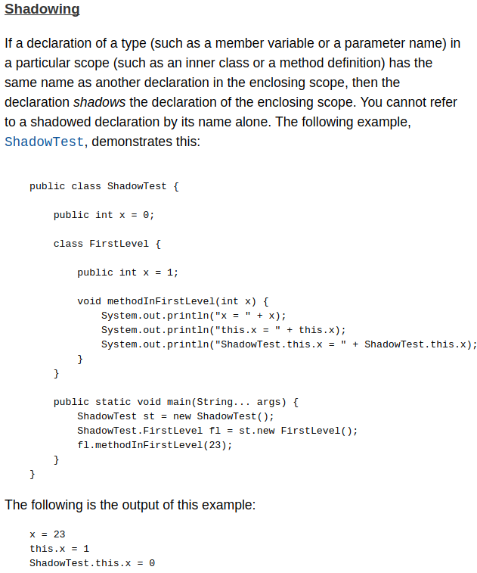

- Serialization of inner classes, including local and anonymous classes, is strongly discouraged.
Some general information

- Don’t try to change the fields directly → dog.name = “Lessy”;
The data should be encapsulated , that means ALWAYS USE GETTER and SETTER
- Getter : name = dog.getName();
- Setter : dog.setName(“Lessy”);
Main is used for creating objects and interacting them with each other.
Formal parameter == Parameter Actual parameter == Argument
Data encapsulation == hiding our Data Getter == Accessors Setters == Mutators

How do you decide if a class should extend another class ?
- “Is A” : Helps you decide if a class should extend another class . Is a “Dog” an “Animal” ? Is a “Dog” a “Cat” ? If the answer to that is yes then it will probably be a good subclass and superclass
- “Has A“ : Helps you decide if something is a field. “Dog” has a “Hight” → makes sense

When to use Inheritance ?
- The subclass Is A superclass , when “Is A” has the answer yes
- When a subclass needs most of the methods in a superclass ( almost every method in Animal is used in Dog)
- Don’t : Use inheritance just to reuse code, or when they don’t have a Is a relationship.

Why use Inheritance ?
- Avoid duplicate code
- Changes to superclass code is instantly reflected in subclasses
- User knows that all subclasses have all of the methods of the superclass

Using setter methods in constructor: bad practice?
- It's probably not a good idea. If you don't make that class final and don't make the setName( ... ) method private or final someone else is able to extend your class and overrid the setName( ... ) method. Your constructor (in your base class) will call that method in the extending class instead of your implementation. Nobody knows what that method can do. As a rule of thumb: a constructor shouldn't call methods that can be overriden.
- in the call of setName(), the subclass constructor hasn't yet been called, so final variables can be uninitialized, etc.

What is a virtual function ? Can you write virtual functions / methods in Java?

Coding interviewers love this question. Yes. Although Java does NOT have a virtual keyword, Java has virtual functions and you can write them.
In object-oriented programming, a virtual function or virtual method is a function or method whose behaviour can be overridden within an inheriting class by a function with the same signature. This concept is a very important part of the polymorphism portion of object-oriented programming

- In Java, all non-static methods are by default "virtual functions.". Examples : Interface methods are "pure virtual" because they are designed to be overridden. Abstract classes contain implicitly "virtual" methods, implemented by classes extending it.
Only certain methods are not virtual :
    - Class methods (static methods)
    - Private instance methods (because is not accessible in any way nor it can be inherited)
    - Final methods (can be inherited but cannot be overriden)
Which members of a superclass will be inherited ? (static methods inherited ?)

- All methods that are accessible are inherited by subclasses.
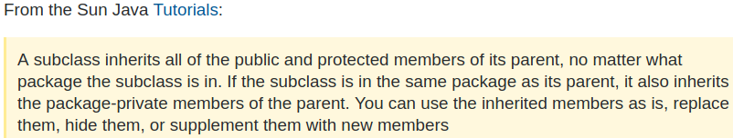
- The only difference with inherited static (class) methods and inherited non-static (instance) methods is that when you write a new static method with the same signature, the old static method is just hidden, not overridden.
- * Final methods can be inherited but cannot be overriden

class SuperClass{
public static void staticMethod(){
System.out.println("SuperClass: inside staticMethod");
}
}
public class SubClass extends SuperClass{

//overriding the static method
public static void staticMethod(){
System.out.println("SubClass: inside staticMethod");
}

public static void main(String []args){

SuperClass superClassWithSuperCons = new SuperClass();
SuperClass superClassWithSubCons = new SubClass();
SubClass subClassWithSubCons = new SubClass();
superClassWithSuperCons.staticMethod();
superClassWithSubCons.staticMethod();
subClassWithSubCons.staticMethod();

}
}

Output:
SuperClass: inside staticMethod
SuperClass: inside staticMethod
SubClass: inside staticMethod

***you certainly don't get the same effect as you get for overriding non-static methods.

Why a final class cannot be inherited but a final method can be inherited?

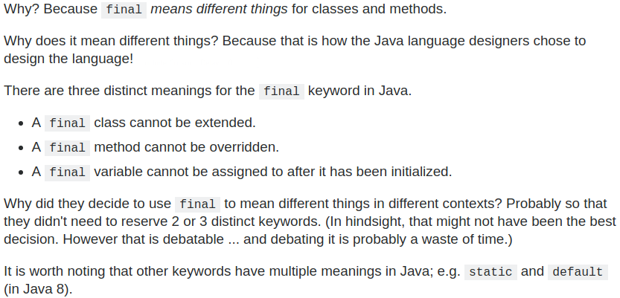

Initializer blocks

In the beginning of Java, initializer blocks (also static blocks) were the only way to do some things, but now they are confusing, error prone, and in most cases have been replaced by better alternatives : https://softwareengineering.stackexchange.com/questions/238820/should-i-use-initializer-blocks-in-java

Initializer block contains the code that is always executed whenever an instance is created. The block of code will execute before the constructor’s code

Instance initializers are executed in the order defined when the class is instantiated, immediately before the constructor code is executed, immediately after the invocation of the super constructor.

- Why use instance initializer block?
Suppose I we to perform some operations while assigning value to instance data member e.g. a for loop to fill a complex array or error handling etc.

Interface

- A class with only abstract methods (no “abstract” keyword for methods) default - static
- You can add as many interfaces to a class as you want
- You can only use public static and final fields
- interfaces provide the ultimate flexibility : Classes from different inheritance trees can use a common interface

Static keyword

The static keyword can be used in 4 scenarios:
- Static variables (class Variable) : All instances share the same copy of the variable. A class variable can be accessed directly with the class, without the need to create a instance. It is a variable which belongs to the class and not to object(instance). Static variables are initialized only once , at the start of the execution .

- Static methods (class Method) : It is a method which belongs to the class and not to the object(instance) .
A static method can access only static data. It can not access non-static data DIRECTLY (instance variables / instance methods) . Meaning a static method (for example main) cannot call an non-static method (directly) like this : sayHello();
A non-static method should be called with an instance : myObject.sayHello();
For static methods you will require an instance (in other words, an object) to invoke instance methods.
We CANT use THIS and SUPER( ) keywords in a static context (static block or static method)
→ this corresponds to Current Instance, → super corresponds to parent Instance .Within static block or static method – you don’t have any instance to refer and hence it’s not permitted to use

public class myClass{

public void doSomething(){
System.out.println("do Something");
}

public static void main(String[] arg){
doSomething(); // Calling a non-static method
} // directly inside a static method
} // this will generate an ERROR !
// new myClass().doSomething(); will work

- Static blocks of code (static initializer) : The static initializer is a static {} block of code inside java class, and run only one time before the constructor or main method is called.
    - executed by virtual machine when class is loaded, ONLY ONCE for all Objects
    - No return statements are supported.
    - No arguments are supported.
    - No this or super are supported.

Java provides a feature called a static initializer that’s designed specifically to let you initialize static fields:

class StaticInit {
public static int x;
static {
x = 32;
}
// other class members such as constructors and
// methods go here...
}

This example is pretty trivial. In fact, you can achieve the same effect just by assigning the value 32 to the variable when it is declared. If, however, you had to perform a complicated calculation to determine the value of x — or if its value comes from a database — a static initializer could be very useful.

- static nested classes
Constructors

- Are the first functions that will be called when an object is created
- Super class constructor (if called explicitly) MUST be in the first line in a constructor
- Constructors must either directly invoke a constructor from the superclass or the compiler will automatically add super() as the first line of the constructor.
- Usually all the test’s and other things will be put in one constructor ( if salary > 0 etc …) and the other constructors will be calling that constructor . Else we need to write the same tests in every single constructor.
- Its a special kind of method , can be called only in some ways (with new, this, super …)
- Default Constructor → If a class doesn’t have a constructor in it, there will be an implicit constructor with no arguments added, or we can define a default constructor. If we define a constructor with arguments , then the default constructor wont be added (Same : C++) so it is good practice to also define a default constructor !

Does an instance of superclass get created when we instantiate a subclass ?
Does java create 2 Objects when a subclass Object is created , one from superclass one from subclass ?

Only ONE OBJECT is created. You're not instantiating two objects, though: you're instantiating one object, and running first the SuperClass and then the SubClass constructor on it.

- The SuperClass constructor is responsible for initializing the parts that were inherited from SuperClass, and the SubClass constructor is responsible for initializing the additional things defined in SubClass.

A single object is created - but that object is an instance of both the superclass and the subclass (and java.lang.Object itself). There aren't three separate objects. There's one object with one set of fields (basically the union of all the fields declared up and down the hierarchy) and one object header.
The constructors are executed all the way up the inheritance hierarchy - but the this reference will be the same for all of those constructors; they're all contributing to the initialization of the single object.

Overriding

- to override an inherited method you are defining the method again in the subclass :
  - Must have the same name
  - Must have the same parameters
  - You can return a different type, as long as it's compatible with the return type of the overridden method.
- There is also something called “Hiding” and it is not the same as overriding !
- Anytime we override a method , we cant change its scope / access modifier ! (?)

Overloading

- Overloading cant be done with only a different return type. Because the compiler wont be able to know which function you are calling when there are 2 functions with the same name and same parameters like :
void eatSomething(String S) and int eatSomething(String S)

Abstract

Some classes will be too general (abstract concepts) to have any instances of it or any kind specific fields. For example the class “Food” , food doesn’t have a shape or a color or a taste that we can set. But apple , fish and so on has those properties and can have instances.
→ We cannot instantiate an abstract class (can’t create objects of it)
→ Abstract methods have no implementations , only signature
→ There are no abstract Fields
→ Fields inside an Abstract class should be private and accessed with protected getters and setters (?)
→ Abstract classes can contain non-abstract methods and static methods
→ Normal classes are also called “Concrete Classes” (not abstract)
So how can we make sure that nobody will be able to create a food object while other classes can still inherit from it and using concept of polymorphism ? → We make the food class “Abstract”
A class will be abstract :
- If a class has the keyword abstract in front of it. abstract public class myClass { … }
- If a method is declared as abstract inside that class, then the class has to be abstract.
- Any class that inherits an abstract class MUST override all the abstract methods that it will get or else that subclass will be also seen as abstract
→ Abstract methods will only have the signature : public abstract void randomMethod();

Superclass type can hold subclass objects

In Java, all non-static methods are based on the runtime type of the underlying object rather than the type of the reference that points to that object. Therefore, it doesn’t matter which type you use in the declaration of the object, the behavior will be the same.
If there are methods present in super class, but overridden by subclass, and if object of subclass is created, then whatever reference we use(either subclass or superclass), it will always be the overridden method in subclass that will be executed.
There are two approaches to refer a subclass object. Both have some advantages/disadvantages over the other. The declaration affect is seen on methods that are visible at compile-time.
- First approach (Referencing using Superclass reference): A reference variable of a superclass can be used to a refer any subclass object derived from that superclass. If the methods are present in SuperClass, but overridden by SubClass, it will be the overridden method that will be executed.
- Second approach (Referencing using subclass reference) : A subclass reference can be used to refer its object.

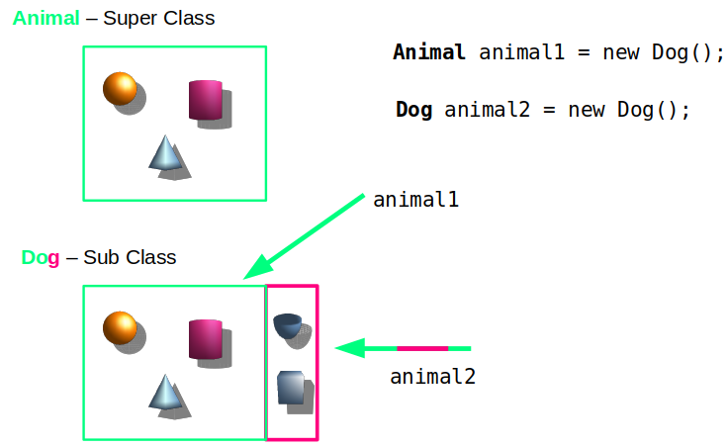

So here we have 2 Objects(instances) . The dog object inherits all the fields and methods that are accessible from the Animal Class (green). The Dog object can also add additional things (fields, methods) to itself , which the Animal class / Object wont have (purple).
The concept of references are similar to pointers in C , we have to tell the compiler what kind of pointer we have. That way it knows which operations are available and what kind of values that pointer will point to. For example Structures in C : When we create a new structure our pointer type will be the type of that structure:
struct list * ptr = malloc(sizeof(struct list));
This way the compiler knows “Alright , this is a struct list pointer , so it will have … variables and etc”.
→ The same is concept is applied here. If we create a new Dog object but give it to an Animal reference, the program only can see that green frame because of the Animal reference. Even though it’s a Dog object and the program knows it , it will only be able to see and work with that green frame of the Dog Object which is shown above with animal1 reference.
→ That means the Dog class can override some methods and if we pass the animal1 reference to a method, the programm will first execute the overriden methods in the SubClass in this case , because our object is a Dog. But there is no way that we can use the new properties (purple) of the Dog class with an Animal reference type !
Advantage : We can use superclass reference to hold any subclass object derived from it. Disadvantage : By using superclass reference, we will have access ONLY to those parts(methods and variables) of the object defined by the superclass.

Annotations

Annotations, a form of metadata, provide data about a program that is not part of the program itself. Annotations have no direct effect on the operation of the code they annotate.
Annotations have a number of uses, among them:
- Information for the compiler — Annotations can be used by the compiler to detect errors or suppress warnings.
- Compile-time and deployment-time processing — Software tools can process annotation information to generate code, XML files, and so forth.
- Runtime processing — Some annotations are available to be examined at runtime.
The annotation can include elements, which can be named or unnamed, and there are values for those elements:
@Author( @SuppressWarnings(value = "unchecked")
name = "Benjamin Franklin", void myMethod() { ... }
date = "3/27/2003"
)
class MyClass() { ... }

It is also possible to use multiple annotations on the same declaration

Where Annotations Can Be Used
Annotations can be applied to declarations: declarations of classes, fields, methods, and other program elements. When used on a declaration, each annotation often appears, by convention, on its own line.
Many annotations replace comments in code.
Suppose that a software group traditionally starts the body of every class with comments providing important information:

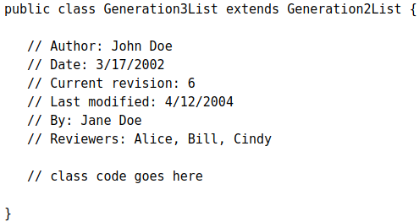
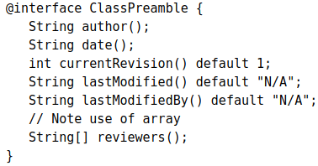

Annotation types are a form of interface

The body of the previous annotation definition contains annotation type element declarations, which look a lot like methods. Note that they can define optional default values.

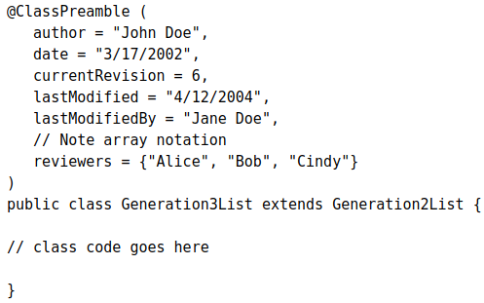
After the annotation type is defined, you can use annotations of that type, with the values filled in, like this:

Predefined Annotation Types

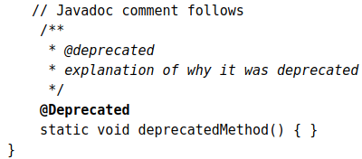
@Deprecated annotation indicates that the marked element is deprecated and should no longer be used. The compiler generates a warning whenever a program uses a method, class, or field with the @Deprecated annotation. When an element is deprecated, it should also be documented using the Javadoc @deprecated tag, as shown in the following example.
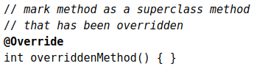
@Override annotation informs the compiler that the element is meant to override an element declared in a superclass.

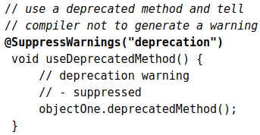
@SuppressWarnings annotation tells the compiler to suppress specific warnings that it would otherwise generate. In the following example, a deprecated method is used, and the compiler usually generates a warning. In this case, however, the annotation causes the warning to be suppressed.

- For example, you want to ensure that a particular variable in your program is never assigned to null; you want to avoid triggering a NullPointerException. You can write a custom plug-in to check for this. You would then modify your code to annotate that particular variable, indicating that it is never assigned to null. The variable declaration might look like this:
@NonNull String str;
When you compile the code, including the NonNull module at the command line, the compiler prints a warning if it detects a potential problem, allowing you to modify the code to avoid the error. After you correct the code to remove all warnings, this particular error will not occur when the program runs.
You can use multiple type-checking modules where each module checks for a different kind of error. In this way, you can build on top of the Java type system, adding specific checks when and where you want them.

Interfaces

An interface is a reference type, similar to a class, that can contain only :
- constants (variables),
- method signatures,
- default methods (defender methods),
- static methods,
- nested types (from other interfaces)

→ Method bodies exist only for default methods and static methods. Interfaces cannot be instantiated—they can only be implemented by classes or extended by other interfaces.
→ an Interface must be either public or package private (no-modifier)
→ An interface can extend any number of interfaces
→ All abstract, default, and static methods in an interface are implicitly public
→ All VARIABLES defined in an interface are implicitly public, static, and final
→ All METHODS are implicitly public (no other option), the public keyword is generally not written
→ By convention, the implements clause follows the extends clause, if there is one.
→ All methods inside an Interface are abstract , except default and static methods ?!
→ default methods are virtual , they can be overridden
→ Java 8 added the ability to add default and static methods to an interface

Evolving Interfaces

If you want to add new methods to an existing Interface , we cant just add a new method because it will break the existing code of the classes that implements that interface. In this case default methods (defender methods) are used (Java 8).
If you want to add additional methods to an interface, you have several options :
- We can create a new Interface that extends the current interface and adds the new functionality we want to add. Now users of your code can choose to continue to use the old interface or to upgrade to the new interface.
- You could also define new static methods to existing interfaces. Users who have classes that implement interfaces enhanced with new default or static methods do not have to modify or recompile them to accommodate the additional methods.
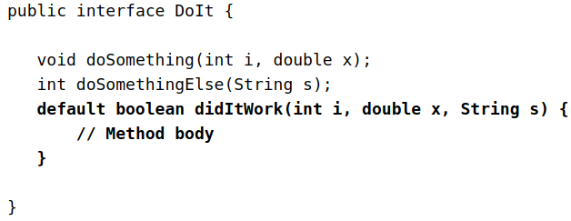
- We can also define our new methods as default. Note that you must provide an implementation for default methods.

In Java, a class can inherit from only one class but it can implement more than one interface. Therefore, objects can have multiple types: the type of their own class and the types of all the interfaces that they implement. This means that if a variable is declared to be the type of an interface, its value can reference any object that is instantiated from any class that implements the interface.
(Java 8 Tutorials) The Java programming language supports multiple inheritance of type, which is the ability of a class to implement more than one interface. When you define a new interface, you are defining a new reference data type. You can use interface names anywhere you can use any other data type name. If you define a reference variable whose type is an interface, any object you assign to it must be an instance of a class that implements the interface.

public class test (C) implements InterfaceFly, InterfaceRun {

void extra () {
System.out.println("Hey");
}

// ... implementation of foo1 and foo2 ...

public static void main(String[] args){

InterfaceFly ptr = new test();
boolean isC = (ptr instanceof test); //true
boolean isI1 = (ptr instanceof InterfaceFly); //true
boolean isI2 = (ptr instanceof InterfaceRun); //true

// our reference ptr is of type 'InterfaceFly'
// meaning it can only see the methods and fields
// that this interface provides
// [ SAME AS USING PARENT CLASS AS REFERENCE TYPE OF SUBCLASS OBJECTS ]
// ptr CANT SEE / FIND any method named ‘extra’
ptr.extra(); // this line gives an ERROR !

// as we can see , the same reference is now able to access
// the method 'extra' because we cast the reference into a 'test' type ( ((test)ptr).extra(); // This is OK !

interface InterfaceFly (I1) {
void foo1();
}
interface InterfaceRun (I2) {
void foo2();
}
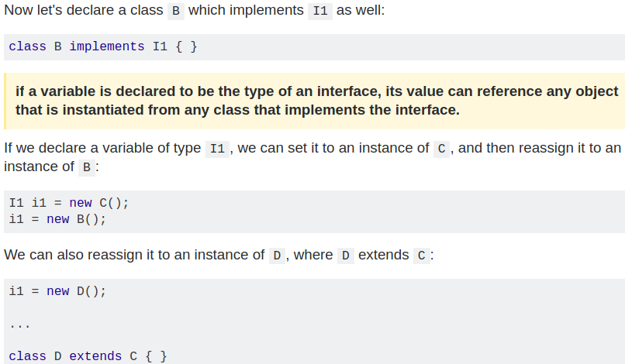
Understanding Interfaces

There are a number of situations in software engineering when it is important for disparate groups of programmers to agree to a "contract" that spells out how their software interacts. Each group should be able to write their code without any knowledge of how the other group's code is written. Generally speaking, interfaces are such contracts.

For example, imagine a futuristic society where computer-controlled robotic cars transport passengers through city streets without a human operator. Automobile manufacturers write software (Java, of course) that operates the automobile—stop, start, accelerate, turn left, and so forth. Another industrial group, electronic guidance instrument manufacturers, make computer systems that receive GPS (Global Positioning System) position data and wireless transmission of traffic conditions and use that information to drive the car.

The auto manufacturers must publish an industry-standard interface that spells out in detail what methods can be invoked to make the car move (any car, from any manufacturer). The guidance manufacturers can then write software that invokes the methods described in the interface to command the car. Neither industrial group needs to know how the other group's software is implemented. In fact, each group considers its software highly proprietary and reserves the right to modify it at any time, as long as it continues to adhere to the published interface.

Interfaces as APIs

The robotic car example shows an interface being used as an industry standard Application Programming Interface (API). APIs are also common in commercial software products. Typically, a company sells a software package that contains complex methods that another company wants to use in its own software product. An example would be a package of digital image processing methods that are sold to companies making end-user graphics programs. The image processing company writes its classes to implement an interface, which it makes public to its customers. The graphics company then invokes the image processing methods using the signatures and return types defined in the interface. While the image processing company's API is made public (to its customers), its implementation of the API is kept as a closely guarded secret—in fact, it may revise the implementation at a later date as long as it continues to implement the original interface that its customers have relied on.

An example of a class in the JDK that implements several interfaces is HashMap, which implements the interfaces Serializable, Cloneable, and Map<K, V>. By reading this list of interfaces, you can infer that an instance of HashMap (regardless of the developer or company who implemented the class) can be cloned, is serializable (which means that it can be converted into a byte stream; see the section Serializable Objects), and has the functionality of a map. In addition, the Map<K, V> interface has been enhanced with many default methods such as merge and forEach that older classes that have implemented this interface do not have to define.

Note that many software libraries use both abstract classes and interfaces; the HashMap class implements several interfaces and also extends the abstract class AbstractMap.

Inheritance

When you want to create a new class and there is already a class that includes some of the code that you want, you can derive your new class from the existing class. In doing this, you can reuse the fields and methods of the existing class without having to write (and debug!) them yourself.
Definitions: A class that is derived (türemek,çıkarmak) from another class is called a subclass (also a derived class, extended class, or child class). The class from which the subclass is derived is called a superclass (also a base class or a parent class).
- Except the Object class (defined in the java.lang package), which has no superclass, every class has one and only one direct superclass (single inheritance). In the absence of any other explicit superclass, every class is implicitly a subclass of Object.
- Classes can be derived from classes that are derived from classes that are derived from classes, and so on, and ultimately derived from the topmost class, Object. Such a class is said to be descended (soyundan olmak) from all the classes in the inheritance chain stretching back to Object.
- A subclass inherits all the members (fields, methods, and nested classes) from its superclass. Constructors are not members, so they are not inherited by subclasses, but the constructor of the superclass can be invoked from the subclass.

A subclass inherits all of the public and protected members of its parent, no matter what package the subclass is in. If the subclass is in the same package as its parent, it also inherits the package-private members of the parent. You can use the inherited members as is, replace them, hide them, or supplement them with new members

You can declare a field in the subclass with the same name as the one in the superclass, thus hiding it (not recommended).

- The inherited fields can be used directly, just like any other fields.
- You can declare a field in the subclass with the same name as the one in the superclass, thus hiding it (not recommended).
- You can declare new fields in the subclass that are not in the superclass.
- The inherited methods can be used directly as they are.
- You can write a new instance method in the subclass that has the same signature as the one in the superclass, thus overriding it.
- You can write a new static method in the subclass that has the same signature as the one in the superclass, thus hiding it.
- You can declare new methods in the subclass that are not in the superclass.
- You can write a subclass constructor that invokes the constructor of the superclass, either implicitly or by using the keyword super.

- A nested class has access to all the private members of its enclosing class—both fields and methods. Therefore, a public or protected nested class inherited by a subclass has indirect access to all of the private members of the superclass.
- As with multiple inheritance of implementation, a class can inherit different implementations of a method defined (as default or static) in the interfaces that it extends. In this case, the compiler or the user must decide which one to use.

Note: Static methods in interfaces are NEVER INHERITED by anyone.
To access them → InterfaceName.staticMethod();

Overriding and Hiding Methods
The ability of a subclass to override a method allows a class to inherit from a superclass whose behavior is "close enough" and then to modify behavior as needed. The overriding method has the same name, number and type of parameters, and return type as the method that it overrides. An overriding method can also return a subtype of the type returned by the overridden method. This subtype is called a covariant return type.
If a subclass defines a static method with the same signature as a static method in the superclass, then the method in the subclass hides the one in the superclass. Note that hiding fields is generally bad programming practice.
The distinction between hiding a static method and overriding an instance method has important implications:
- The version of the overridden instance method that gets invoked is the one in the subclass.
- The version of the hidden static method that gets invoked depends on whether it is invoked from the superclass or the subclass.

public class Animal {

public static void testClassMethod() {
System.out.println("The static method in Animal");
}
public void testInstanceMethod() {
System.out.println("The instance method in Animal");
}
}
public class Cat extends Animal {

public static void testClassMethod() {
System.out.println("The static method in Cat");
}
public void testInstanceMethod() {
System.out.println("The instance method in Cat");
}
public static void main(String[] args) {
Cat myCat = new Cat();
Animal myAnimal = myCat; Output:The static method in Animal
Animal.testClassMethod(); The instance method in Cat
myAnimal.testInstanceMethod();
}
}

Default methods and abstract methods in interfaces are inherited like instance methods. However, when the supertypes of a class or interface provide multiple default methods with the same signature, the Java compiler follows inheritance rules to resolve the name conflict. These rules are driven by the following two principles:
- Instance methods are preferred over interface default methods. If a class extends a superclass and also implemets interfaces and if both (the superclass and interfaces) have the same methods, the subclass will prefer to use the method which it inherited from its parent class
- Methods that are already overridden by other candidates are ignored. This circumstance can arise when supertypes share a common ancestor. This is for default methods ? Interfaces can override default methods , so if a class implements a parent and a child interface, that class will use the default method that was last overriden (the method in the child interface)
If two or more independently defined default methods conflict, or a default method conflicts with an abstract method, then the Java compiler produces a compiler error. You must explicitly override the supertype methods.

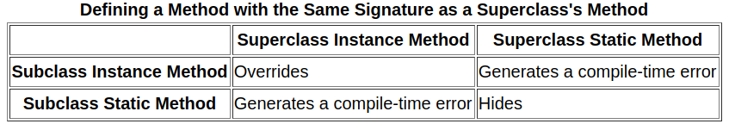

Note: In a subclass, you can overload the methods inherited from the superclass. Such overloaded methods neither hide nor override the superclass instance methods—they are new methods, unique to the subclass.

Modifiers
The access specifier for an overriding method can allow more, but not less, access than the overridden method. For example, a protected instance method in the superclass can be made public, but not private, in the subclass. Meaning we cannot assign weaker access privileges

Polymorphism

The dictionary definition of polymorphism refers to a principle in biology in which an organism or species can have many different forms or stages. This principle can also be applied to object-oriented programming and languages like the Java language. Subclasses of a class can define their own unique behaviors and yet share some of the same functionality of the parent class.
Polymorphism can be demonstrated with a minor modification to the Bicycle class. For example, a printDescription method could be added to the class that displays all the data currently stored in an instance.
To summarize, there are three classes: Bicycle, MountainBike, and RoadBike. The two subclasses override the printDescription method and print unique information.

public class TestBikes {

public static void main(String[] args){

Bicycle bike01, bike02, bike03;

bike01 = new Bicycle(20, 10, 1);
bike02 = new MountainBike(20, 10, 5, "Dual");
bike03 = new RoadBike(40, 20, 8, 23);

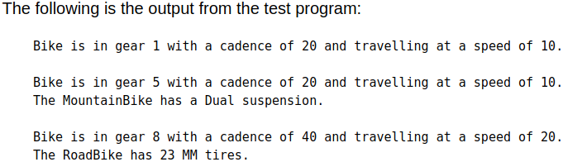
bike01.printDescription();
bike02.printDescription();
bike03.printDescription();
}
}

The Java virtual machine (JVM) calls the appropriate method for the object that is referred to in each variable. It does not call the method that is defined by the variable's type. This behavior is referred to as virtual method invocation and demonstrates an aspect of the important polymorphism features in the Java language.

Using the Keyword super

If your method overrides one of its superclass's methods, you can invoke the overridden method through the use of the keyword super. You can also use super to refer to a hidden field (although hiding fields is discouraged).
- The super keyword can also invoke a superclass's constructors. Invocation of a superclass constructor must be the first line in the subclass constructor.
With super(), the superclass no-argument constructor is called. With super(parameter list), the superclass constructor with a matching parameter list is called.
- Note: If a constructor does not explicitly invoke a superclass constructor, the Java compiler automatically inserts a call to the no-argument constructor of the superclass. If the super class does not have a no-argument constructor, you will get a compile-time error. Object does have such a constructor, so if Object is the only superclass, there is no problem.
If a subclass constructor invokes a constructor of its superclass, either explicitly or implicitly, you might think that there will be a whole chain of constructors called, all the way back to the constructor of Object. In fact, this is the case. It is called constructor chaining, and you need to be aware of it when there is a long line of class descent.

Object as a Superclass

The Object class, in the java.lang package, sits at the top of the class hierarchy tree. Every class is a descendant, direct or indirect, of the Object class. Every class you use or write inherits the instance methods of Object. You need not use any of these methods, but, if you choose to do so, you may need to override them with code that is specific to your class. The methods inherited from Object that are discussed in this section are:

protected Object clone() throws CloneNotSupportedException
Creates and returns a copy of this object.

public boolean equals (Object obj)
Indicates whether some other object is "equal to" this one.

protected void finalize() throws Throwable
Called by the garbage collector on an object when garbage collection determines that there are no more references to the object

public final Class getClass()
Returns the runtime class of an object.

public int hashCode()
Returns a hash code value for the object.

public String toString()
Returns a string representation of the object.

Note: There are some subtle aspects to a number of these methods, especially the clone method.

Writing Final Classes and Methods

You can declare some or all of a class's methods final. You use the final keyword in a method declaration to indicate that the method cannot be overridden by subclasses. The Object class does this—a number of its methods are final.
- You might wish to make a method final if it has an implementation that should not be changed and it is critical to the consistent state of the object.
- Methods called from constructors should generally be declared final. If a constructor calls a non-final method, a subclass may redefine that method with surprising or undesirable results.
- Note that you can also declare an entire class final. A class that is declared final cannot be subclassed. This is particularly useful, for example, when creating an immutable class like the String class.

Abstract Objects and Classes

An abstract class is a class that is declared abstract—it may or may not include abstract methods. Abstract classes cannot be instantiated, but they can be subclassed. An abstract method is a method that is declared without an implementation (without braces, and followed by a semicolon)
- If a class includes abstract methods, then the class itself must be declared abstract
- When an abstract class is subclassed, the subclass usually provides implementations for all of the abstract methods in its parent class. However, if it does not, then the subclass must also be declared abstract.
- An abstract class may have static fields and static methods. You can use these static members with a class reference (for example, AbstractClass.staticMethod()) as you would with any other class.
Note: Methods in an interface (see the Interfaces section) that are not declared as default or static are implicitly abstract, so the abstract modifier is not used with interface methods. (It can be used, but it is unnecessary.)

Abstract Classes Compared to Interfaces

Abstract classes are similar to interfaces. You cannot instantiate them, and they may contain a mix of methods declared with or without an implementation. However, with abstract classes, you can declare fields that are not static and final, and define public, protected, and private concrete methods. With interfaces, all fields are automatically public, static, and final, and all methods that you declare or define (as default methods) are public. In addition, you can extend only one class, whether or not it is abstract, whereas you can implement any number of interfaces.

An Abstract Class Example : In an object-oriented drawing application, you can draw circles, rectangles, lines, Bezier curves, and many other graphic objects. These objects all have certain states (for example: position, orientation, line color, fill color) and behaviors (for example: moveTo, rotate, resize, draw) in common. Some of these states and behaviors are the same for all graphic objects (for example: position, fill color, and moveTo). Others require different implementations (for example, resize or draw). All GraphicObjects must be able to draw or resize themselves; they just differ in how they do it. This is a perfect situation for an abstract superclass. You can take advantage of the similarities and declare all the graphic objects to inherit from the same abstract parent object (for example, GraphicObject)
Which should you use, abstract classes or interfaces?

Consider using abstract classes if any of these statements apply to your situation:
- You want to share code among several closely related classes.
- You expect that classes that extend your abstract class have many common methods or fields, or require access modifiers other than public (such as protected and private).
- You want to declare non-static or non-final fields. This enables you to define methods that can access and modify the state of the object to which they belong.
Consider using interfaces if any of these statements apply to your situation:
- You expect that unrelated classes would implement your interface. For example, the interfaces Comparable and Cloneable are implemented by many unrelated classes.
- You want to specify the behavior of a particular data type, but not concerned about who implements its behavior.
- You want to take advantage of multiple inheritance of type.

